**Goal:**

1. Generate a algorithm in matlab which can provide energy requirement of the vehicle.
2. Calculate the Motor speed (rpm) for the vehicle to run 90 km/hr.
3. Calculate the Motor power(W) for the vehicle to run 90 km/hr.

**Inputs variables**

|  |  |  |
| --- | --- | --- |
| **Input variables** | **Vehicle-1** | **Vehicle-2** |
| **Kerb weight(kg)** | 1000 | 1000 |
| **Payload(kg)** | 500 | 250 |
| **Gravitational force** | 9.81 | 9.81 |
| **Air density(kg/m3)** | 1.225 | 1.225 |
| **Width(m)** | 1.8 | 1.8 |
| **Height(m)** | 1 | 1 |
| **Frontal Area(m)** | 1.8 | 1.8 |
| **Drag coefficient** | 0.2 | 0.2 |
| **grade_angle(deg)** | 15 | 15 |

**Additional Information**

* Consider European Driving cycle for velocity profile
* Gear Ratio, g = 7.
* Tire Size - 90/100 R10 53J

**Deliverable**

1. Generate below plot

* **Rolling resistance vs Velocity (M-S)**

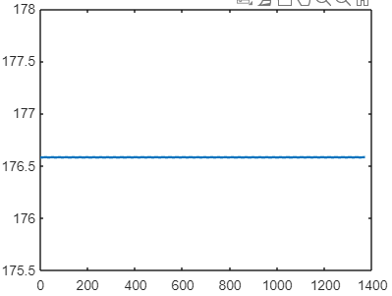

* **Air resistance vs Velocity (M-S)**

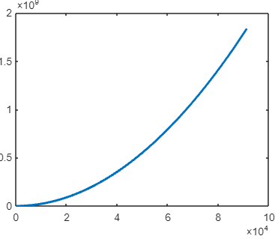

* **Grade resistance vs Velocity (M-S)**

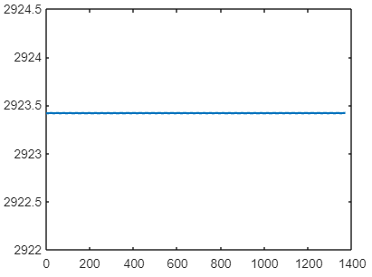

* **Total resistance(N) vs Velocity(M-S)-Plot**

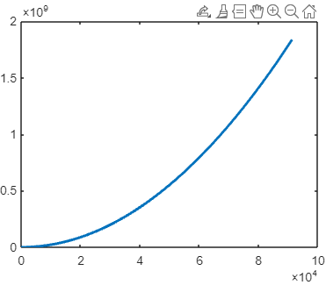

* **Total Power (W) vs Velocity (M-S)-Plot**

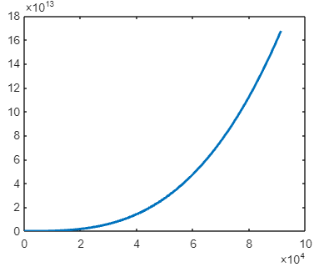

* **Energy Consumed (J) vs Velocity (M-S)-Plot**

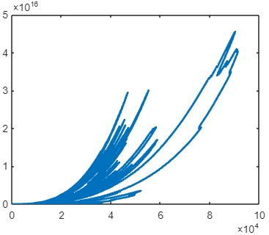

* **Drive cycle plot- Time(S) vs Velocity (M-S)**

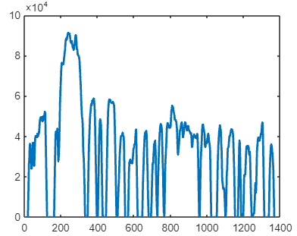

2) **RPM of the motor to maintain vehicle speed of 20m/s**

* Gear Ratio, g = 7.
* Tire Size - 90/100 R10 53J = 0.254 meters

Ans :

Motor RPM = (Vehicle Speed * Gear Ratio)/ Tyre Diameter

Motor RPM = (20* 7)/ 0.254

Motor RPM = 551.18 RPM

1. **Generate a algorithm in matlab which can provide energy requirement of the vehicle**.

Ans : Please refer attached Project_power_sizing.m file for matlab algorithm, also the same code is pasted below.

clear all;

clc;

%Input_variables

Kerb_Weight=1000%(kg)

Payload=500%(kg)

Coefficient_of_rolling_resistance=0.012

Air_density=1.225%(kg/m^3)

Frontal_area=1.8%(m^2)

Drag_coefficient_=0.2

grade_angle=0.2%radiance

%drive_cycle_input

Driving_cycle=readtable('DRIVE_CYCLE-EUDC.xlsx')

Time=Driving_cycle{:,1};

Velocity=Driving_cycle{:,2}

VelocityInMeters=0

Energy = 0

%Govering_equation

for i=1:1370

VelocityInMeters(i) = Velocity(i)* 1609

R_rolling(i)=(Payload+Kerb_Weight)*Coefficient_of_rolling_resistance*9.81

R_air(i)=0.5*Air_density*Frontal_area*Drag_coefficient_*VelocityInMeters(i)*VelocityInMeters(i)

R_grade(i)=(Payload+Kerb_Weight)*9.81*sin(grade_angle)

%Total_resistance

total_resistance(i)=R_rolling(i)+R_air(i)+R_grade(i)

Power(i)=total_resistance(i)*VelocityInMeters(i)

Energy(i) = Power(i)*Time(i)

end

figure

plot(Time,R_rolling,'linewidth',2)

hold on

plot(Time,R_grade,'linewidth',2)

hold on

plot(VelocityInMeters,R_air,'linewidth',2)

hold on

plot(VelocityInMeters,total_resistance,'linewidth',2)

hold on

plot(VelocityInMeters,Power,'linewidth',2)

hold on

plot(VelocityInMeters,Energy,'linewidth',2)

hold on

plot(Time,VelocityInMeters,'linewidth',2)

hold on

1. **Calculate the Motor speed (rpm) for the vehicle to run 90 km/hr.**

* Gear Ratio, g = 7.
* Tire Size - 90/100 R10 53J = 0.254 meters

Ans :

Motor RPM = (Vehicle Speed * Gear Ratio)/ Tyre Diameter

Motor RPM = (252525* 7)/ 0.254

**Motor RPM = 689 RPM**

1. **Calculate the Motor power(W) for the vehicle to run 90 km/hr.**

Ans:

Power(W) = Total resistance * Velocity

Power(W) = 3230 * 25

**Power(W) = 80750 Watt**